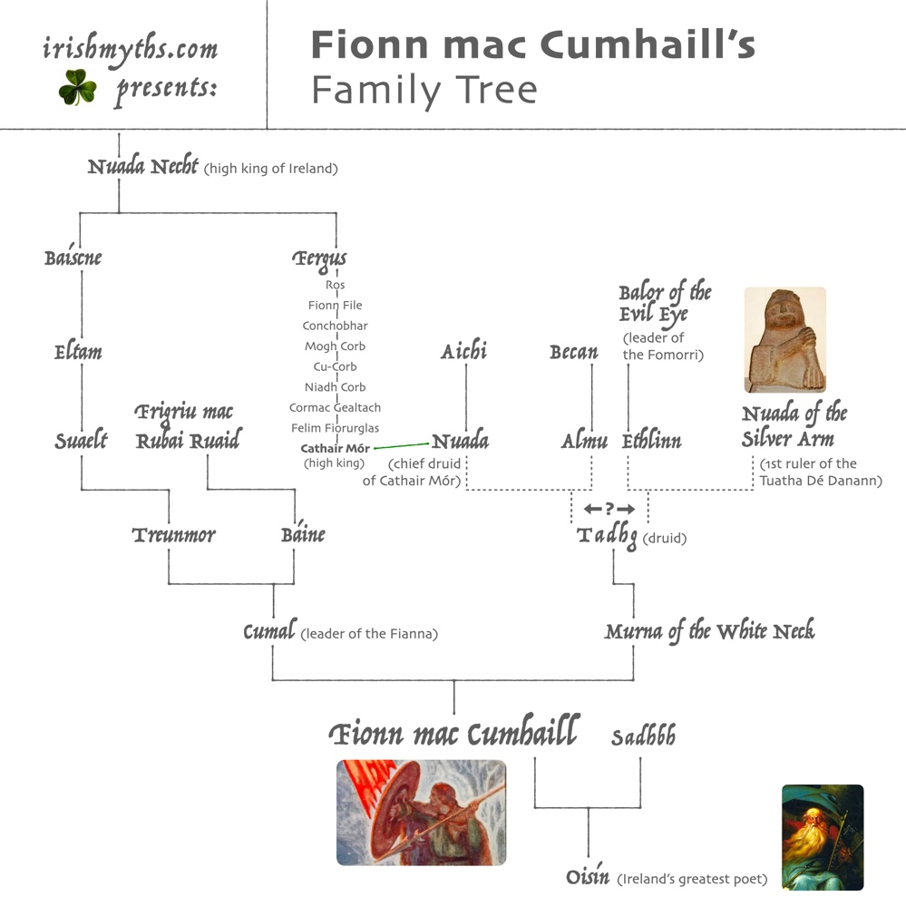

**TIME OF ABRAHAM**

300 years

 

**TOWER OF BABEL**

*Settlement of Ireland by PARTHOLÓN and his people; 10 years of peace followed by war with FOMORIANS*

*Partholonians wiped out by plague, except forTuán mac Cairill*

230 years

*Noah’s granddaughter, CESSAIR, comes to Ireland only 40 days before the Flood; all her companions drown except for Fintan mac Bóchra*

**NOAH’S FLOOD**

**CREATION OF WORLD**

*Time of Fénius Farsaid and his grandson Goídel Glas, ancestors of the GAELS*

30 years

217 years

*GAELS migrate to Egypt*

132

This content downloaded from

147.26.36.137 on Thu, 16 Mar 2023 15:39:36 UTC

All use subject to https://about.jstor.org/terms

*A second group of ancestral Nemedians, who have lived in the North and developed magical powers, return to Ireland as the TÚATHA DÉ DANANN*

*One group of Nemedians, formerly enslaved in Greece, returns to Ireland as the FIR BOLG, FIR DOMNANN, and GAILEÓIN*

*NEMEDIANS*

*drowned by tide during battle; survivors scattered*

*Settlement of Ireland by NEMED and his people; war with FOMORIANS*

37 years 440 years



*GAELS leave Egypt and begin further peregrinations*

*Settlement of GAELS in Iberian peninsula*

**TIME OF THE EXODUS**

*TÚATHA DÉ DANANN*

*dominant in Ireland*

*Arrival of GAELS* (now called MILESIANS)

*from Iberian peninsula*

*Defeat of TÚATHA DÉ DANANN by GAELS/MILESIANS and division of Ireland*

*Defeat of FIR BOLG by TÚATHA DÉ DANANN*

(first Battle of Moytura)

*Defeat of FOMORIANS by TÚATHA DÉ DANANN*

(second Battle of Moytura)

150 years

fig. 4.1. The timeline of Irish prehistory in ‘The Book of Invasions’.

JAPHET,

son of NOAH

**NEMEDIANS**

Unnamed brother

PARTHOLÓN

*All except Tuán mac Cairill are wiped out by plague, after successfully battling the Fomorians.*

*Tuán survives in successive animal forms*

**PARTHOLONIANS**

**GAELS (’MILESIANS’)**

FÉNIUS FARSAID

**NOAH**

CESSAIR

(daughter of BITH) ― FINTAN mac BÓCHRA

*All except Fintan are drowned in the Flood. Fintan survives a further 5,500 years in various animal forms*

**PEOPLE OF CESSAIR**

BITH,

son of NOAH

NEMED

*All are wiped out by a flood, except for remnants who are scattered*

BREGON

GOÍDEL GLAS

133

This content downloaded from

147.26.36.137 on Thu, 16 Mar 2023 15:39:36 UTC

All use subject to https://about.jstor.org/terms

fiG. 4.2. The invaders in ‘The Book of Invasions

MÍL ESPÁINE

uncle of ÍTH

ÉREMÓN

ÉBER

ÍTH

**FOMORIANS**

*Apparently always indigenous, sometimes traced back to CAIN, son of ADAM*

*Migration to Iberian peninsula*

FIR DOMNANN

**FIR BOLG**

*Ancestral Nemedians enslaved in Greece*

*Ancestral Nemedians who are scattered to the North but who remain autonomous and grow skilled in the magical arts*

**TÚATHA DÉ DANANN**

GAILEÓIN

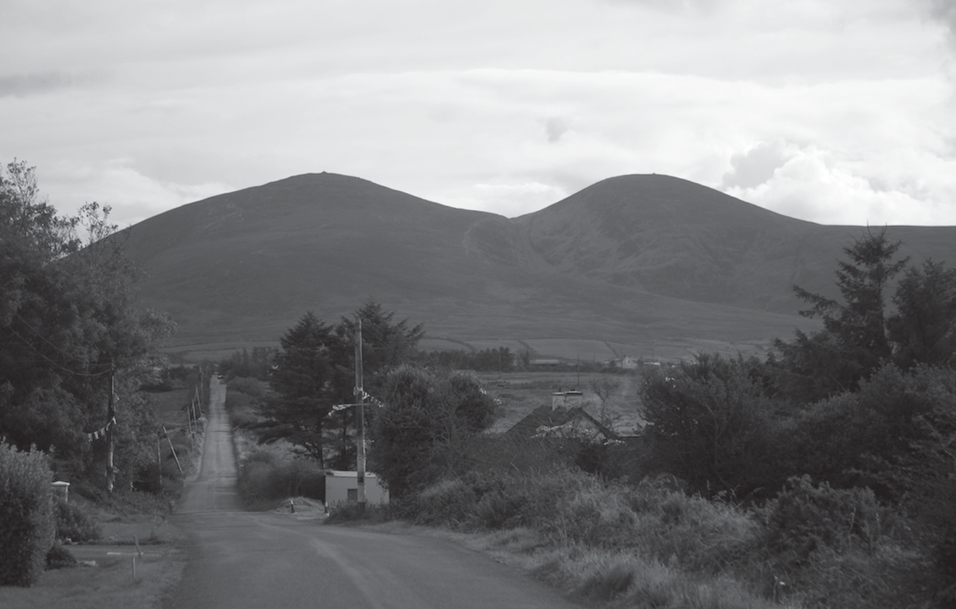

fig. 4.4. The Paps Mountains, Co. Kerry—the breasts of the ‘mother of the Irish gods’?

Photo: Gerard Lovett.

H U M AN , A L L TO O H U M AN

Like the unknown first compiler of *Lebor Gabála*, my role in this chapter has been to effect a synthesis out of a mass of data originally expounded by others, and it is time to consider some larger patterns. Scholars have long lamented that Irish myth is not really a mythol- ogy in the usual Indo-European way: archaic elements have been inex- tricably interwoven with biblical and medieval material. This mythopo- etic tendency accelerated remarkably in the late tenth and eleventh centuries, with the result that in this period ‘Irish mythology’ actually came into existence as a distinct cultural category. The great edifice of the national pseudohistory allotted to the gods their own era of emi- nence in the deep past, with a list of personnel and a clear timeline; it was at this point too that they acquired their lasting name, Túatha Dé Danann.

Ecclesiastical *literati* in the period had become more and more inter- ested in the lore of the *filid*, and as they built up a narrative of the na- tional past, they foraged from the professional poets’ genealogies, im- ages, and ideas about the native gods. The *filid* in turn—anxious about losing their distinctiveness and being absorbed into clerical ranks—may increasingly have begun to use the gods to personify and allegorize as- pects of their own intellectual curriculum, as well as to underscore the secular status of their profession.

The effect of the pseudohistory was paradoxical. On the one hand, it gave solidity to the fluid ontology of the gods by defining them as human magic-workers and tracing their descent from Noah. As intrinsically na- tive figures, with no connection to the Bible, working the gods into the pseudohistory was a remarkable achievement; Ireland was now fur- nished with a new national myth that fused the natural and supernatu- ral. On the other hand, the result was unwieldy and unstable, continu- ously expanding by the copious accretion of authorities.

The influence of the doctrines of *Lebor Gabála* on Irish letters, though substantial, was patchy. The idea that the gods had died out (or were among the damned) never took hold in most narrative genres, and some simply ignored it. The whole point of the synthetic history had been to connect the story of Ireland’s ancient past to that of the rest of the world, but the native god-peoples were unavoidably parochial: until the nine- teenth century no one outside Ireland and Scotland took any notice of the Túatha Dé Danann. A case in point is the twelfth-century Cambro- Norman cleric Gerald of Wales, who gives a rundown of the Irish ac- count of the past in his *Topographia Hiberniae* (‘Topography of Ireland’). He sensibly asks how anything could be known about the fate of Cessair, because, after all, she and all her company drowned. ‘Perhaps some re- cord of these events was found inscribed on stone or a tile, as we read was the case with the art of music before the Flood’, he drily com ments.197 Gerald clearly had access to a chronology of the invasions be- cause he describes Cessair, Partholón, Nemed, the Fir Bolg, and the Mile- sians in full. In contrast, he passes over the Túatha Dé Danann so quickly that one could miss them altogether: they are described as ‘an- other branch of the descendants of Nemedius’—Nemed—and that is it.198 All the adventures and achievements of the god-peoples are compressed into a single colourless clause. Gerald clearly felt the historical narrative of the Irish past was worth recording, but it seems he could summon up no interest in the doings of the Túatha Dé. To an outsider, the Irish gods were so native as to be beneath notice—a pattern that prevailed for cen- turies to come.

1. Gerald of Wales, *Topographia Hibernie*, ed. J. J. O’Meara, *PRIA* 52 (C) (1948–50), 113–78, at 157.
2. *Topographia Hibernie*, ed. O’Meara, 160.